What the Maintenance Crew needs to understand about the ADA and Playground Surfaces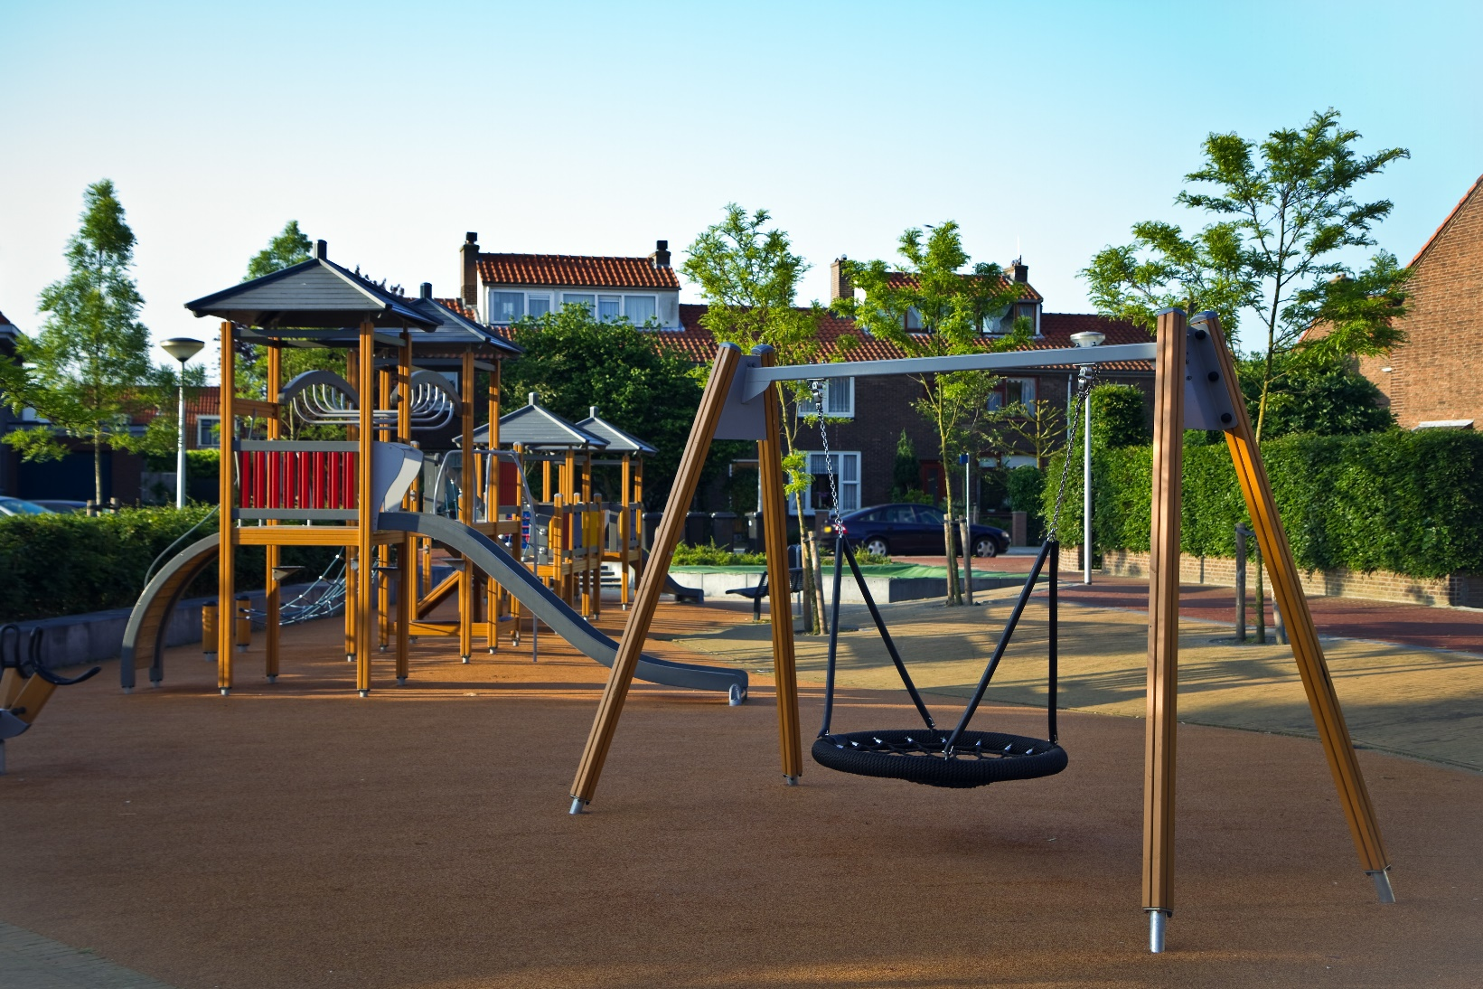
The Americans with Disabilities Act is a Civil rights law modeled after the Civil Rights Act of 1964, and the role of a maintenance crew for a Park and Recreation Department is the first line of defense for children with disabilities to play with their friends, unrestricted by playground surfaces they can’t use.
My sincerest hope when creating this document is to present the important information in plain language, something that anyone without a background in accessibility compliance can understand, to the people who have the most ability to influence the day-to-day impact on children with disabilities. I encourage the reader who this information is intended for to think of this particular task as an important civic duty which will only help the local community to prosper.

Get involved as early as possible
Depending on the decisions of the Parks Department, the playgrounds accessible surface could be installed by the manufacturer, an independent contractor, or by the maintenance staff.
All available maintenance staff should be present during the installation process to get an understanding of what exactly the surface is made from, the layers beneath the top surface, and how it is installed. This familiarity will allow the maintenance staff to do a better job of maintaining the surfacing over time and identifying defects in the accessible route.

What is the Accessible Route?
- The Accessible Route is what makes it possible for a person with a disability to use a playground. This can either be a child with a disability or a parent with a disability taking their children to the park. The Accessible Route should connect all the accessible play equipment within a playground.
- The accessible route is a path free from physical barriers that would prevent a person from traveling along it in a wheelchair.
- Curbs, steps, large cracks, large gaps, holes, uneven surfaces are all things that can make the Accessible Route impossible to travel along.
- Gaps wider than ½” are not allowed
- A lip along the Accessible Route, or other sudden change in level such as a possible the transition from concrete to softer playground surface, shouldn’t be more than ¼” if it’s vertical, and a ½” at most if the top of sloped or beveled.
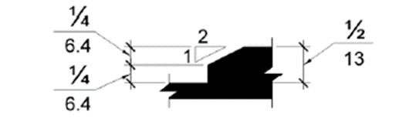
- Inspecting the Accessible Route is a vital action to allowing all children to participate in a normal childhood activity.
- There is a minimum width of the Accessible Route which should be maintained, kept clear from debris.
- The width if the Accessible Route leading up to the playground area from the parking lot or public sidewalk should be at least 36” that is kept clear from obstructions.
- The width of the Accessible route within the playground should be at least 60 inches*. Divots, sunken areas, and missing surface fill areas within the Accessible Route are important to repair or report.
- *In play areas less than 1000 square feet, the clear width of Accessible Routes is allowed to be at least 44 inches, if at least one turning space is provided where the narrow Accessible Route is longer than 30 feet. A turning space is mostly easily a 60” circle of flat and clear space.
- If the Accessible Route begins to slope in the direction of travel, realize the most slope allowed is 6.25%. Anything steeper than 6.25% will need to be repaired.
- The cross slope (perpendicular to direction of travel) has a maximum slope of 2.08%.
- The Accessible Route should also be available for people with blindness to use, so keeping the space clear from tree branches to a height of at least 80 inches above the ground is also important.
- A 30- x 48-inch clear ground space is required at the exit points of play equipment, including slides, swings, and anywhere else a child might exit a play piece. This are should also not exceed 2.08%.

What tools will I need?
The basic tools to keep track of accessibility in a playground are simply a measuring tape and a 2-foot digital level. If not supplied with these tools on a regular basis, please advocate to your supervisor that you need them to do your job properly.
Maintenance Checklist:
- Can you identify the complete Accessible Route?
- Entry area, clear ground space at transfer systems of elevated play areas, clear ground space at accessible ground-level play equipment, clear ground at exit areas of play equipment, the segmented routes that connect required play components along a continuous route.
- Is the running slope for the Accessible Route less than 6.25%?
- Is the cross slope for the Accessible Route less than 2.08%?
- Is the ground level Accessible Route at least 60 inches wide (*some exceptions apply)?
- Are openings in the surface for the Accessible Route bigger than 1/2 inch?
- Are changes in level along the Accessible Route less than 1/2 inch beveled?
- Is the vertical clearance at least 80 inches for the ground level accessible route, including tree branches?
- Does the clear ground space, 30- x 48- inch, at exit of accessible equipment have a cross slope less than 2.08%?
For specific insight on maintenance issues with particular surfaces, please consult page 18 of the original document published by the Access Board which this informal guidance is based upon.
https://www.access-board.gov/attachments/article/1666/play-surfaces.pdf
If you have any further questions about how to measure for accessibility or what to look for when doing so, please contact the RMADAC. We are a free resource that is here to help you understand the ADA.
The above information is informal guidance on common accessibility issues associated with accessible playground surfaces. Much of the information comes directly from a document entitled “7 Things Every Playground Owner Should Know About the Accessibility of Their Playground Surfaces” published by the United States Access Board https://www.access-board.gov/attachments/article/1666/play-surfaces.pdf

